2.1

a

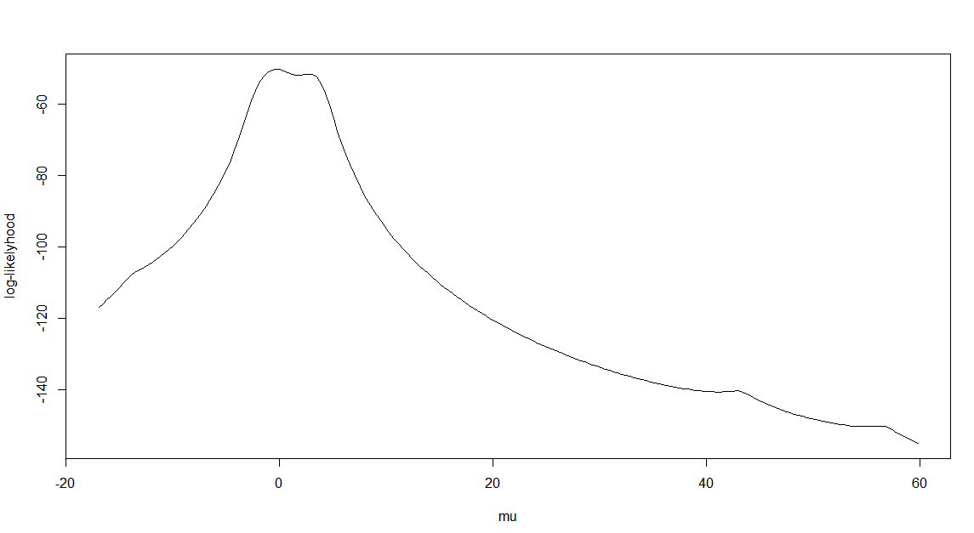

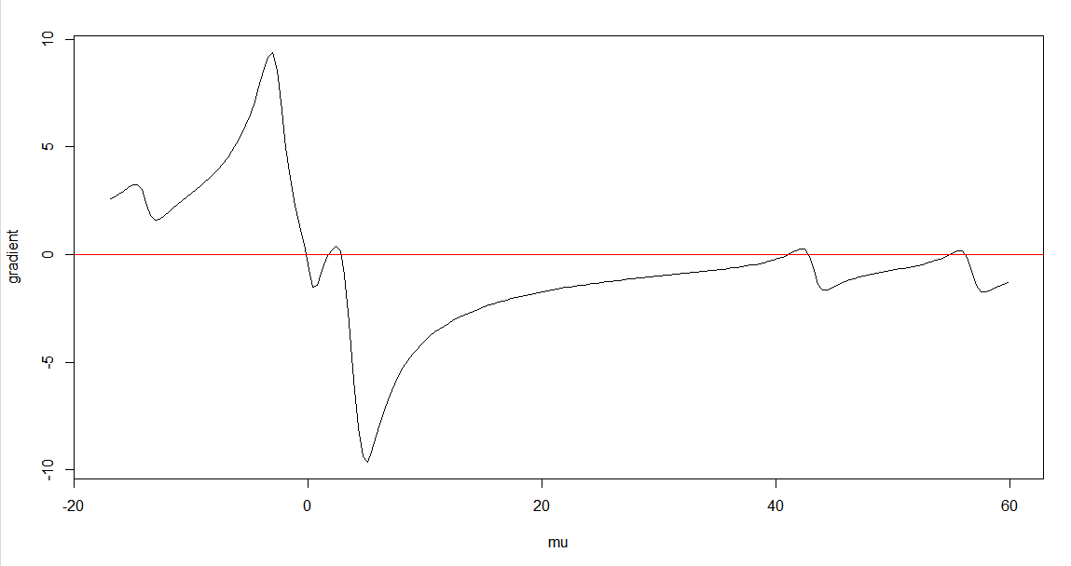

Using Newton



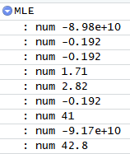 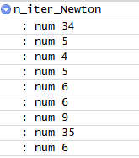

We can see that starting point -11 and 8 gave no analytical solution (you will also see the following warning in R in the case of 8 and -11)



This indicates that no root can be calculated using these two starting points. When starting point is -11, the updated mu will only go leftward on the mu axis, where there will be no root according to the plot of gradient. When the starting point is 8, it seems that there are roots that can be found to the right of mu=8 on the mu axis, but the reality is that a certain step of updating mu has skipped all 4 roots to the right of mu=8, causing no roots found. This means that the Newton method in this case is unstable to some degree, sensitive to starting point selection. Other starting points gave roots which agrees with the gradient plot.

Although Newton method does find the roots of the gradient function, the roots are not the same and only roots obtained with starting point -1 and 0 gave the true MLE of mu (by checking the log-likelihood plot). It is understandable since this log-likelihood plot is continuous and has multiple convex intervals.

If you use mean of the data, which is 5.106, the computed MLE is 54.9, which is not the global MLE. It is not a good starting point in this case since the mean of data is not a good estimate of the true mean (the weight (probability) of each data sampled from the distribution should be considered in calculating the true mean).

b

Using -1 and 1 as starting points will result in the convergence at the global MLE:

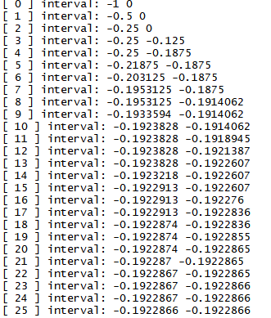

Above is the output of each iteration of the customized bisection method. 25 iterations gave the right MLE.

Let’s run the bisection method with some other starting points that will NOT result in finding the global MLE.

Example 1.

starting with [min(X)+qt(0.1, df=1), max(X)+qt(0.9, df=1)] interval which is the widest interval we can use.

The result is as follows:

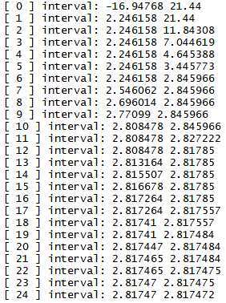

After about 20 iterations it is already showing the tendency to converge at 2.81, which is a root of the gradient function but not the global MLE.

Example 2.

Then we change the starting interval into [-1,2] where the global MLE approximately resides.

The result is as follows:



This is because the value of the gradient function at these two starting points multiply and give a result >0, which triggers the following code in the bisection function:



This means that for complicated function like our gradient function of the Cauchy loglikelihood, starting interval has to be carefully chosen.

Example 3.

Then we change the starting interval into [20,42.7] which does not contain the global MLE.

Result:

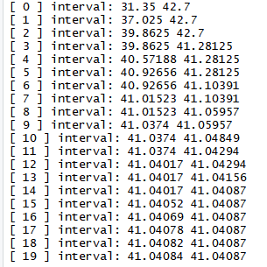

After several iterations it shows the tendency of converging at 41.0, which is not the global MLE.

c.

To permit convergence, α must be chosen to satisfy



on an interval including the starting value. Our g is the loglikelihood function, g’ is the gradient function.

A series of result of running our fixed-point method is listed below.

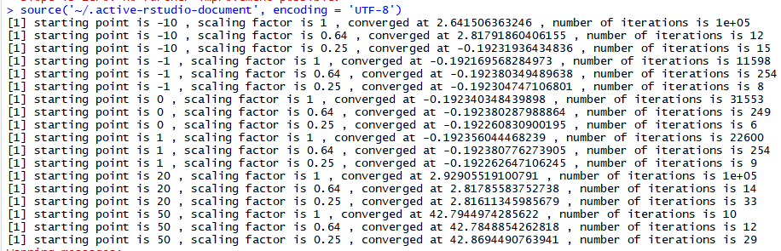

When starting point is -10, scaling factor=1 makes the converging process very slow (not converging after reaching the maximum iteration of 1e5). Scaling factor= 0.64 leads to fast convergence at the local MLE not the global MLE, while scaling factor=0.25 converges fast at the global MLE.

Starting point=-1 makes the converging happened at the global MLE for all three alphas, but the speed of convergence increases while value of alpha decreases from 1 to 0.25.

Starting point=0 and starting point=1 are similar to the case where starting point=-1.

Starting point=20 will never converge at the global MLE, and is slow when alpha=1, a lot faster when alpha=0.64 or 0.25.

Starting point=50 will never converge at the global MLE and converges fast at local MLE of 42.8 when alpha = 1 or 0.64, and at local MLE of 42.9 when alpha = 0.25

d

Using different starting intervals and the secant result is as follows:



We can see that (-1,1) interval produces the global MLE in 8 iterations, very fast. While using (min(X)+qt(0.1, df=1), max(X)+qt(0.9, df=1)) interval and (20,60) interval do not give a convergence. When using (-3, 3) interval, the MLE quickly converged at a local MLE, not the global MLE.

e

Newton–Raphson method, bisection, ﬁxed-point iteration, and the secant method

Speed:

From the above questions (a to d) we can see that Newton–Raphson method and secant method are fast, they usually converge at some MLE within a few iterations when using proper starting intervals. Bisection method is slower than Newton but still fast, it usually converges a few tens of iterations. The speed of fixed-point method is subject to the choice of scaling factor. A bad scaling factor can make the calculation as slow as to take more than 1e5 iterations and still not converging, while a good scaling factor can make the convergence happen within few iterations.

Stability:

Newton–Raphson method, bisection method and secant method are sensitive to the choice of initial conditions. There is a chance that they may not converge if you randomly choose starting points/intervals. Fixed-point method is much more stable and will almost always converge, no matter what initial condition you use.

2.2

a

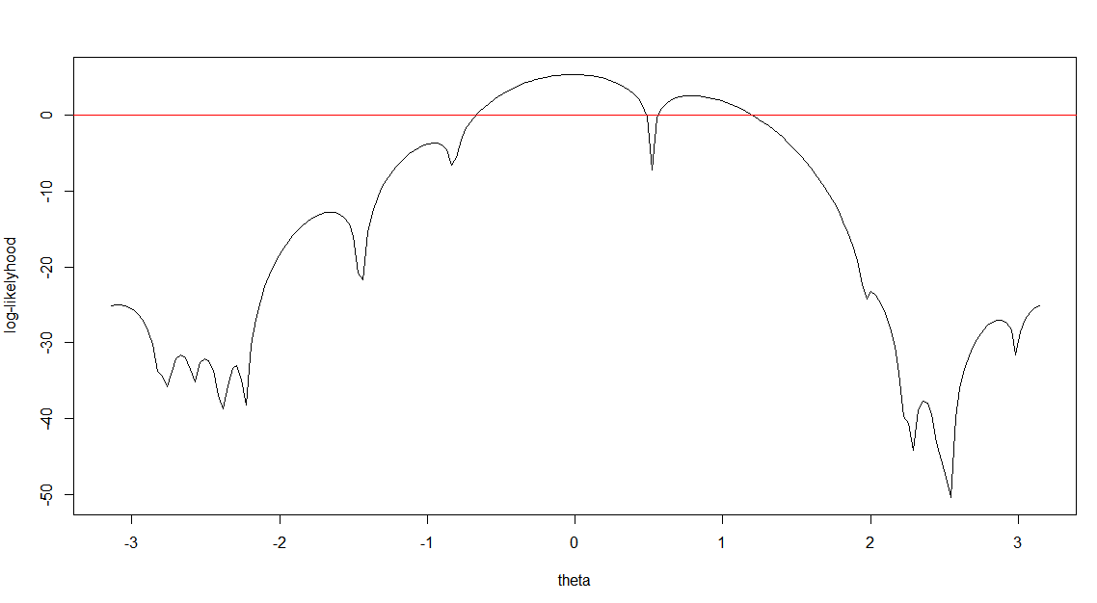

b

$$method-of-moments estimator=\int_{0}^{2π}{x*f\left(x\right)} =\int_{0}^{2π}{-\frac{\left(2xsin\left(x-θ\right)+2\cos\left(x-θ\right)-x^{2}\right)}{4π}}=πE\left(X\right)+sinθ=0.0619$$

c

We use starting points in the following sequence: $0.0619, -2.7, 2.7$

Resulting MLEs:

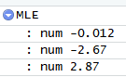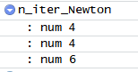

d

See the table of MLE result and its starting point. MLEs are group by colors

|  |  |
| --- | --- |
| MLE | starting point |
| -3.09309173 | -3.141592654 |
| -3.09309173 | -3.110018858 |
| -3.09309173 | -3.078445063 |
| -3.09309173 | -3.046871267 |
| -3.09309173 | -3.015297472 |
| -3.09309173 | -2.983723676 |
| -3.09309173 | -2.952149881 |
| -3.09309173 | -2.920576085 |
| -3.09309173 | -2.889002289 |
| -3.09309173 | -2.857428494 |
| -3.09309173 | -2.825854698 |
| -2.786166752 | -2.794280903 |
| -2.786166752 | -2.762707107 |
| -2.666699926 | -2.731133312 |
| -2.666699926 | -2.699559516 |
| -2.666699926 | -2.667985721 |
| -2.666699926 | -2.636411925 |
| -2.666699926 | -2.60483813 |
| -2.507613226 | -2.573264334 |
| -2.507613226 | -2.541690539 |
| -2.507613226 | -2.510116743 |
| -2.507613226 | -2.478542948 |
| -2.507613226 | -2.446969152 |
| -2.507613226 | -2.415395357 |
| -2.388200492 | -2.383821561 |
| -2.29725622 | -2.352247766 |
| -2.29725622 | -2.32067397 |
| -2.29725622 | -2.289100175 |
| -2.29725622 | -2.257526379 |
| -2.232167292 | -2.225952584 |
| -1.65828323 | -2.194378788 |
| -1.65828323 | -2.162804993 |
| -1.65828323 | -2.131231197 |
| -1.65828323 | -2.099657402 |
| -1.65828323 | -2.068083606 |
| -1.65828323 | -2.036509811 |
| -1.65828323 | -2.004936015 |
| -1.65828323 | -1.97336222 |
| -1.65828323 | -1.941788424 |
| -1.65828323 | -1.910214629 |
| -1.65828323 | -1.878640833 |
| -1.65828323 | -1.847067038 |
| -1.65828323 | -1.815493242 |
| -1.65828323 | -1.783919447 |
| -1.65828323 | -1.752345651 |
| -1.65828323 | -1.720771855 |
| -1.65828323 | -1.68919806 |
| -1.65828323 | -1.657624264 |
| -1.65828323 | -1.626050469 |
| -1.65828323 | -1.594476673 |
| -1.65828323 | -1.562902878 |
| -1.65828323 | -1.531329082 |
| -1.65828323 | -1.499755287 |
| -1.65828323 | -1.468181491 |
| -1.447478765 | -1.436607696 |
| -0.953336328 | -1.4050339 |
| -0.953336328 | -1.373460105 |
| -0.953336328 | -1.341886309 |
| -0.953336328 | -1.310312514 |
| -0.953336328 | -1.278738718 |
| -0.953336328 | -1.247164923 |
| -0.953336328 | -1.215591127 |
| -0.953336328 | -1.184017332 |
| -0.953336328 | -1.152443536 |
| -0.953336328 | -1.120869741 |
| -0.953336328 | -1.089295945 |
| -0.953336328 | -1.05772215 |
| -0.953336328 | -1.026148354 |
| -0.953336328 | -0.994574559 |
| -0.953336328 | -0.963000763 |
| -0.953336328 | -0.931426968 |
| -0.953336328 | -0.899853172 |
| -0.953336328 | -0.868279377 |
| -0.953336328 | -0.836705581 |
| -0.011972002 | -0.805131786 |
| -0.011972002 | -0.77355799 |
| -0.011972002 | -0.741984195 |
| -0.011972002 | -0.710410399 |
| -0.011972002 | -0.678836604 |
| -0.011972002 | -0.647262808 |
| -0.011972002 | -0.615689013 |
| -0.011972002 | -0.584115217 |
| -0.011972002 | -0.552541421 |
| -0.011972002 | -0.520967626 |
| -0.011972002 | -0.48939383 |
| -0.011972002 | -0.457820035 |
| -0.011972002 | -0.426246239 |
| -0.011972002 | -0.394672444 |
| -0.011972002 | -0.363098648 |
| -0.011972002 | -0.331524853 |
| -0.011972002 | -0.299951057 |
| -0.011972002 | -0.268377262 |
| -0.011972002 | -0.236803466 |
| -0.011972002 | -0.205229671 |
| -0.011972002 | -0.173655875 |
| -0.011972002 | -0.14208208 |
| -0.011972002 | -0.110508284 |
| -0.011972002 | -0.078934489 |
| -0.011972002 | -0.047360693 |
| -0.011972002 | -0.015786898 |
| -0.011972002 | 0.015786898 |
| -0.011972002 | 0.047360693 |
| -0.011972002 | 0.078934489 |
| -0.011972002 | 0.110508284 |
| -0.011972002 | 0.14208208 |
| -0.011972002 | 0.173655875 |
| -0.011972002 | 0.205229671 |
| -0.011972002 | 0.236803466 |
| -0.011972002 | 0.268377262 |
| -0.011972002 | 0.299951057 |
| -0.011972002 | 0.331524853 |
| -0.011972002 | 0.363098648 |
| -0.011972002 | 0.394672444 |
| -0.011972002 | 0.426246239 |
| -0.011972002 | 0.457820035 |
| -0.011972002 | 0.48939383 |
| 0.79060131 | 0.520967626 |
| 0.79060131 | 0.552541421 |
| 0.79060131 | 0.584115217 |
| 0.79060131 | 0.615689013 |
| 0.79060131 | 0.647262808 |
| 0.79060131 | 0.678836604 |
| 0.79060131 | 0.710410399 |
| 0.79060131 | 0.741984195 |
| 0.79060131 | 0.77355799 |
| 0.79060131 | 0.805131786 |
| 0.79060131 | 0.836705581 |
| 0.79060131 | 0.868279377 |
| 0.79060131 | 0.899853172 |
| 0.79060131 | 0.931426968 |
| 0.79060131 | 0.963000763 |
| 0.79060131 | 0.994574559 |
| 0.79060131 | 1.026148354 |
| 0.79060131 | 1.05772215 |
| 0.79060131 | 1.089295945 |
| 0.79060131 | 1.120869741 |
| 0.79060131 | 1.152443536 |
| 0.79060131 | 1.184017332 |
| 0.79060131 | 1.215591127 |
| 0.79060131 | 1.247164923 |
| 0.79060131 | 1.278738718 |
| 0.79060131 | 1.310312514 |
| 0.79060131 | 1.341886309 |
| 0.79060131 | 1.373460105 |
| 0.79060131 | 1.4050339 |
| 0.79060131 | 1.436607696 |
| 0.79060131 | 1.468181491 |
| 0.79060131 | 1.499755287 |
| 0.79060131 | 1.531329082 |
| 0.79060131 | 1.562902878 |
| 0.79060131 | 1.594476673 |
| 0.79060131 | 1.626050469 |
| 0.79060131 | 1.657624264 |
| 0.79060131 | 1.68919806 |
| 0.79060131 | 1.720771855 |
| 0.79060131 | 1.752345651 |
| 0.79060131 | 1.783919447 |
| 0.79060131 | 1.815493242 |
| 0.79060131 | 1.847067038 |
| 0.79060131 | 1.878640833 |
| 0.79060131 | 1.910214629 |
| 0.79060131 | 1.941788424 |
| 2.003644889 | 1.97336222 |
| 2.003644889 | 2.004936015 |
| 2.003644889 | 2.036509811 |
| 2.003644889 | 2.068083606 |
| 2.003644889 | 2.099657402 |
| 2.003644889 | 2.131231197 |
| 2.003644889 | 2.162804993 |
| 2.003644889 | 2.194378788 |
| 2.236219387 | 2.225952584 |
| 2.236219387 | 2.257526379 |
| 2.360718174 | 2.289100175 |
| 2.360718174 | 2.32067397 |
| 2.360718174 | 2.352247766 |
| 2.360718174 | 2.383821561 |
| 2.360718174 | 2.415395357 |
| 2.360718174 | 2.446969152 |
| 2.475373629 | 2.478542948 |
| 2.513593178 | 2.510116743 |
| 2.873094514 | 2.541690539 |
| 2.873094514 | 2.573264334 |
| 2.873094514 | 2.60483813 |
| 2.873094514 | 2.636411925 |
| 2.873094514 | 2.667985721 |
| 2.873094514 | 2.699559516 |
| 2.873094514 | 2.731133312 |
| 2.873094514 | 2.762707107 |
| 2.873094514 | 2.794280903 |
| 2.873094514 | 2.825854698 |
| 2.873094514 | 2.857428494 |
| 2.873094514 | 2.889002289 |
| 2.873094514 | 2.920576085 |
| 2.873094514 | 2.952149881 |
| 2.873094514 | 2.983723676 |
| 3.190093577 | 3.015297472 |
| 3.190093577 | 3.046871267 |
| 3.190093577 | 3.078445063 |
| 3.190093577 | 3.110018858 |
| 3.190093577 | 3.141592654 |

We can interpret the result by looking at the plot of the gradient function, and we have 17 groups of MLEs in the above table. It is understandable

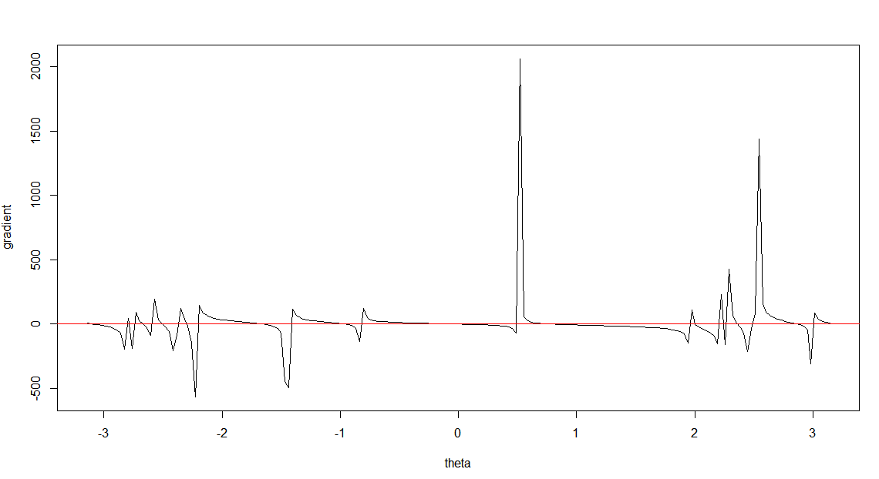

This function has 27 roots between -pi and pi, by looking at its intersection with the red line. We found less groups than the actual number of roots, it is because Newton’s method does not guarantee finding the nearest root to a certain starting point. We missed some roots.

e

We sample many points with the same interval between -2.5 and -2.38 and use them as starting points to calculate MLE. Below shows the result of the first pair of two stating points giving different MLE (-2.404 and -2.402).



2.3

a

If patient is dead, let $L_{i}$ be the individual likelihood of each data,

$$\log{L_{i}}=\log{f(t_{i})}=\log{(λ\left(t_{i}\right)\exp\left(x_{i}^{T}β-Λ\left(t_{i}\right)\exp\left(x_{i}^{T}β\right)\right)) }=\log{λ\left(t_{i}\right)}+x_{i}^{T}β-u_{i}=\log{λ\left(t_{i}\right)}+\log{\frac{u_{i}}{λ\left(t_{i}\right)}}-u_{i}=w_{i}\log{u_{i}}-u_{i}+w_{i}\log{\frac{λ\left(t_{i}\right)}{Λ\left(t_{i}\right)}}$$

Thus

$$\log{L}=\sum_{1}^{n}{\log{L_{i}}}=\sum_{1}^{n}{\left(w_{i}\log{u_{i}}-u_{i}\right)}+\sum_{1}^{n}{w_{i}\log{\frac{λ\left(t_{i}\right)}{Λ\left(t_{i}\right)}}}$$

If patient is alive, $w_{i}=0$

$$\log{L_{i}}=\log{S(t_{i})}=\log{\exp\left(-Λ\left(t_{i}\right)\exp\left(x_{i}^{T}β\right)\right)}=-u_{i}=\sum_{1}^{n}{\left(0*\log{u_{i}}-u_{i}\right)}+\sum_{1}^{n}{0*\log{\frac{λ\left(t_{i}\right)}{Λ\left(t_{i}\right)}}}$$

Q.E.D.

b

if $Λ\left(t_{i}\right)=t_{i}^{α}$, $x_{i}^{T}β=β_{0}+δ_{i}β_{1}$

$$u_{i}=Λ\left(t_{i}\right)\exp\left(β_{0}+δ_{i}β_{1}\right)=t_{i}^{α}\exp\left(β_{0}+δ_{i}β_{1}\right)$$

the loglikelihood function becomes

$$\log{L}=\sum_{1}^{n}{\left(w_{i}\log{u_{i}}-u_{i}\right)}+\sum_{1}^{n}{w_{i}\log{\frac{α{t_{i}^{α-1}}^{}}{t_{i}^{α}}}}=\sum_{1}^{n}{\left(w_{i}\log{t_{i}^{α}\exp\left(β_{0}+δ_{i}β_{1}\right)}-t_{i}^{α}\exp\left(β_{0}+δ_{i}β_{1}\right)\right)}+\sum_{1}^{n}{{αw}_{i}\log{\frac{1}{t_{i}}}}$$

Then we code the Newton-Raphson method and run it with initial condition ($α=1, β_{0}=1,β_{1}=1)$. The result is as follows: 

The MLE of the parameters are ($α=-26.11457, β_{0}=-46.67766,β_{1}=147.18919)$, number of iteration is 7061 before convergence.

C

Used a package to calculate MLE and output the summary as follows

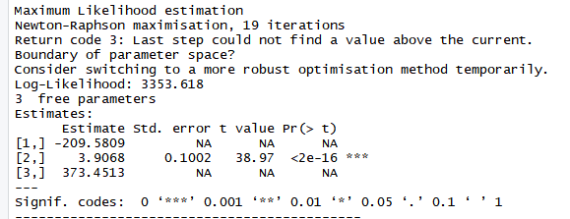

d

The sd of the MLEs are in the above summary. The first and third parameter did not converge using the given initial condition. The second parameter converged, and the standard error is 0.1002

e

Please refer to the code

2.3

a

a = $α$, b= $β0$, c= $β1$, d = $δ$

d/da=



d/db=



d/dc=

